WEEK 3 TASK REPORT/LOGBOOK

Student Name: Precious Jaiyesimi Eniola
Admission number: BIT/2024/39050
Course: Mobile Application Development
School/Faculty: Computing and Informatics, Mount Kenya University_
Program: Information Technology
Academic Year: 4th
Semester: First
Lecturer: Mr Nyoro

Demonstrations
Figma screenshots of Prototype connections and splash screen
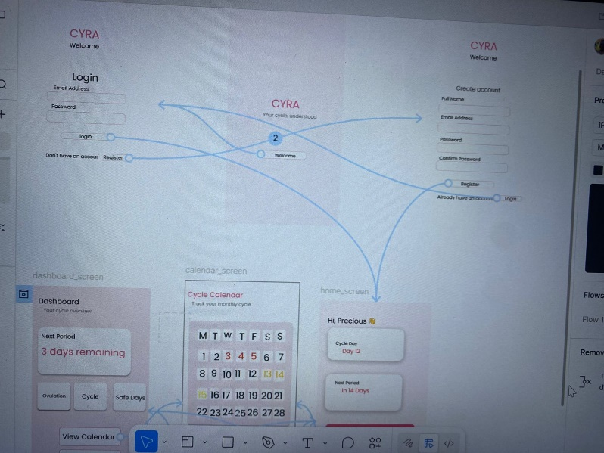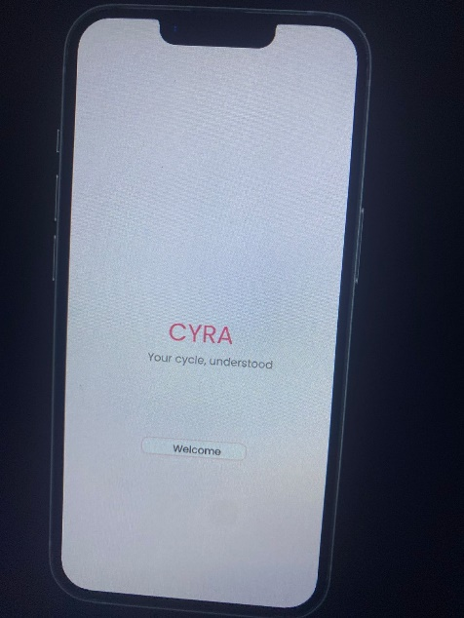

Figma screenshots of Login and Registration
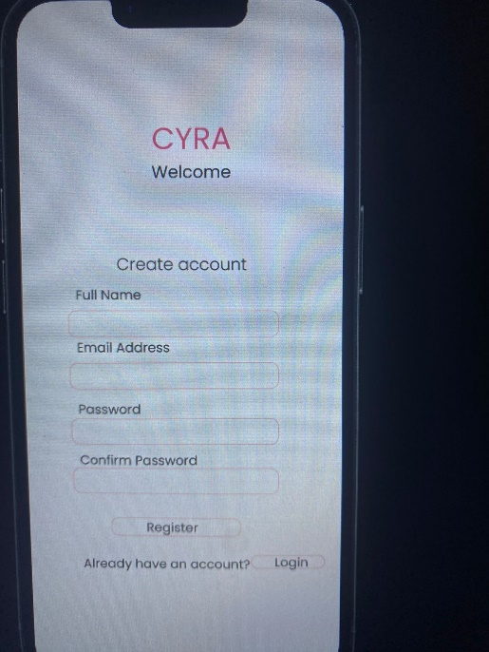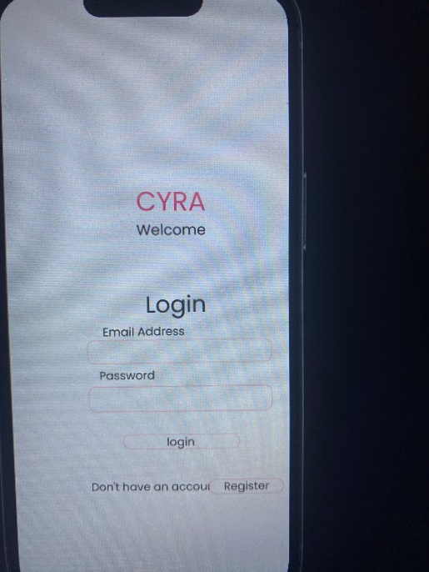
Figma screenshots of Home and dash board
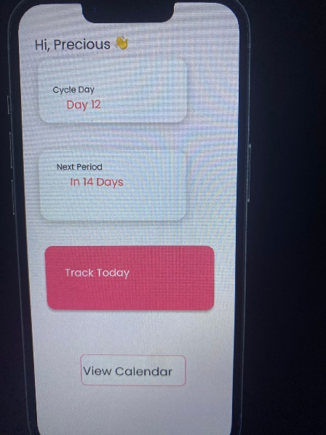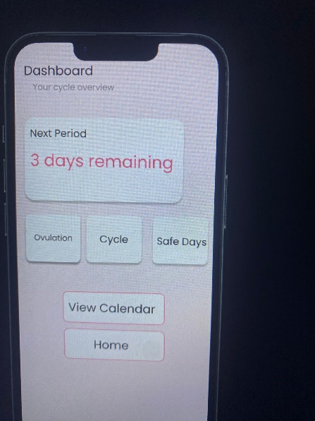

Figma screenshots of calendar
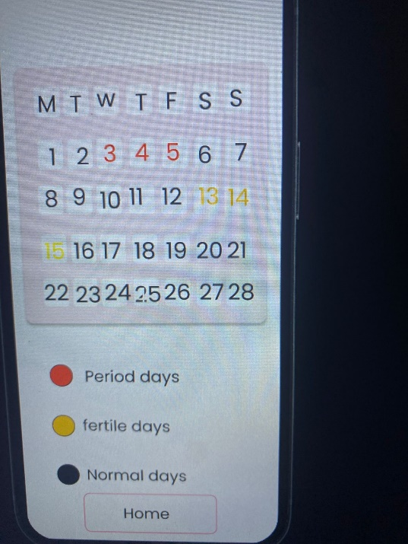

Emulator screenshots
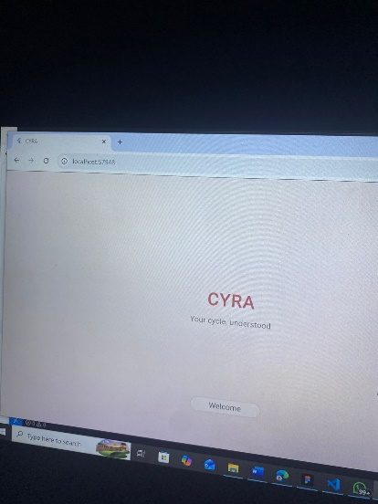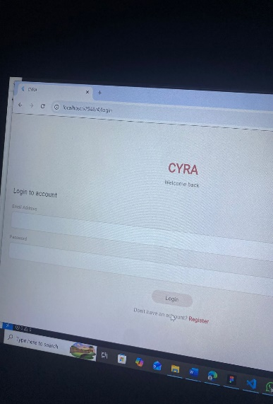
Splash screen Login

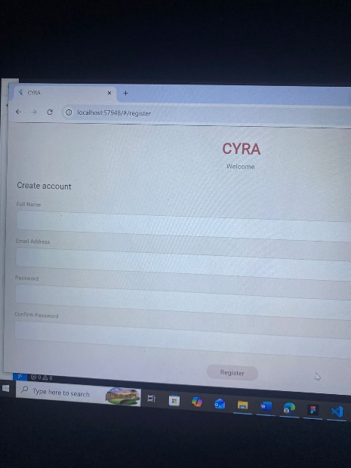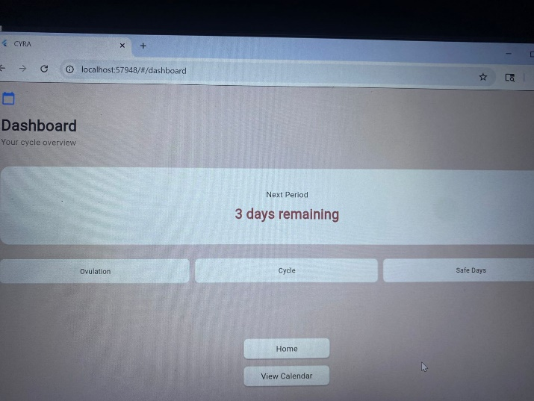
Registration Dashboard
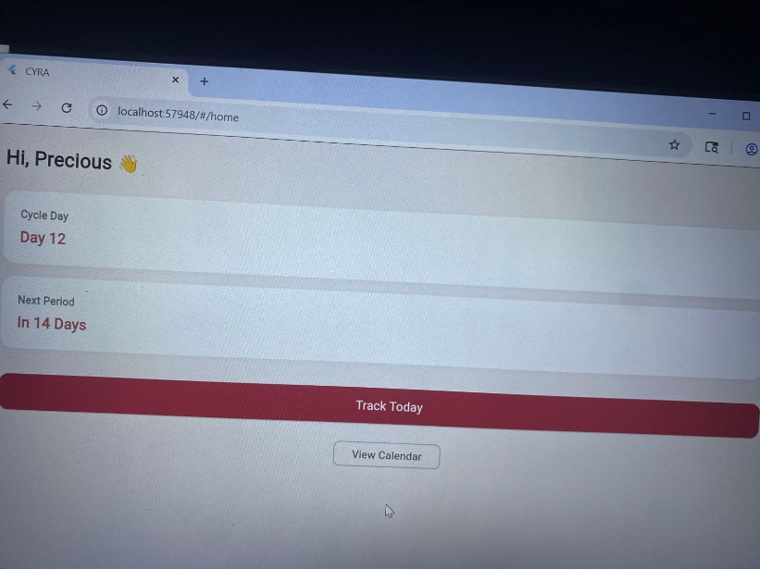
Home
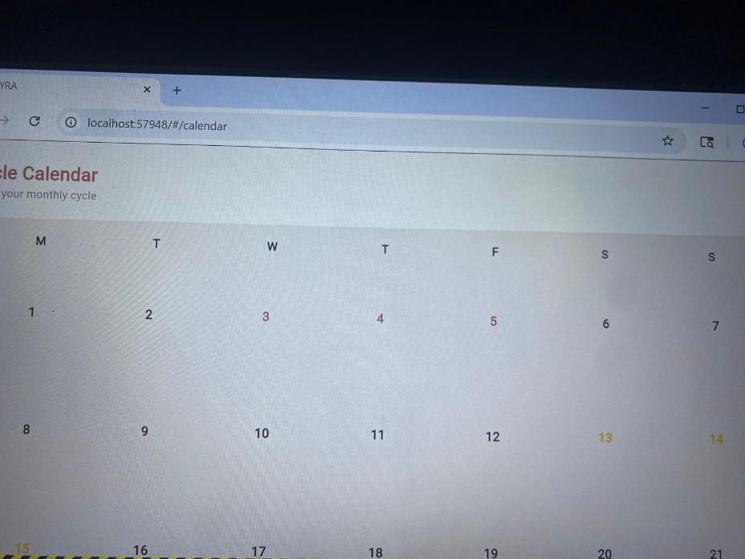
Calendar

TOOLS USED
- FIGMA
- FLUTTER
- VS CODE
- DART

Personal Reflection
Working on the Cyra App gave me practical experience in designing user interfaces and improving the overall user experience of a mobile application. I learned how to create multiple screens, maintain a consistent design, and structure an application effectively. The project enhanced my creativity and technical skills while helping me understand the importance of planning and usability in app development. Overall, it was a valuable learning experience that contributed to my growth as a developer.

